**Online Analysis Website**

A Project Report Submitted in Partial Fulfillment of the requirements

For the award of the degree of

**Bachelor Degree**

**In**

**Computer Science And Engineering**

**by**

Himanshu Sharma (171500138)

Muskan Varshney (171500197)

Varsha Varshney (171500375)

Jyoti Gupta (171500149)

Under the Guidance of

**Mr. Pankaj Kapoor**

**(Asst. Professor)**

Department of Computer Engineering & Applications

**Institute of Engineering & Technology**



**GLA University**

**Mathura- 281406, INDIA**

**2019**

**Department of computer Engineering and Applications**

**GLA University, Mathura**

**17 km. Stone NH#2, Mathura-Delhi Road, P.O. – Chaumuha,**

**Mathura – 281406**



**Declaration**

We hereby declare that the work which is being presented in the B.Tech Project “**Online Analysis Website”** in partial fulfillment of the requirements for the award of the ***Bachelor of Technology*** in Computer Science and Engineering and submitted to the Department of Computer Engineering and Applications of GLA University, Mathura, is an authentic record of my own work carried under the supervision of **Mr. Pankaj Kapoor, Asst.Professor,**

The Content of this project report, in full or in parts, have not beensubmitted to any other Institute or University for the award of any degree.

Sign Sign

Candidate: Varsha Varshney Name of Candidate: Muskan Varshney

University Roll. No. :171500375 University Roll. No. :171500197

Sign Sign \_\_\_\_\_\_\_\_\_\_\_\_\_\_\_\_\_\_\_\_\_\_\_

Name of Candidate: Jyoti Gupta Name of Candidate:Himanshu Sharma

University Roll. No. :171500149 University Roll. No. :171500138

**Acknowledgement**

It gives us a great sense of pleasure to present the report of the B.Tech Mini Project undertaken during B.tech, 3rd Year, This Project in itself is an acknowledgement to the inspiration, drive and technical Assistance contributed to it by many individuals. This project would never have seen the light of the day without the help and Guidance that we have received.

We Owe Special Debt of gratitude to **Mr. Pankaj Kapoor(Asst. Professor)Department of CEA**, for his constant support and guidance throughout the course of our work. His Sincerity, thoroughness and perseverance have been a constant source of inspiration for us. He has showered us with all his extensively experienced ideas and insightful comments at virtually all stages if the project & has also taught us about the latest industry-oriented technologies.

We also do not like to miss the opportunity to acknowledge the contribution of all faculty members of the department for their kind guidance and cooperation during the development of our project. Last but not least, we acknowledge our friends for their contribution in the completion of the project.

**Varsha Varshney**

**Jyoti Gupta**

**Himanshu Sharma**

**Muskan Varshney**

**Abstract**

This project is aimed at developing a Web application that depicts network Analysis. The network analysis is a method used to analyze, control and monitoring of business processes and work flows. This web application involves all the features to reduce congestion in the network.Using this software, companies can improve the efficiency of their network services.

This application is entitled to solve a specific network problem.The congestion control mechanism has been responsible for maintaining stability as the Internet scaled up by many orders of magnitude in size, speed, traffic volume, coverage, and complexity over the last three decades. In this book, we develop a coherent theory of congestion control from the ground up to help understand and design these algorithms. We model network traffic as fluids that flow from sources to destinations and model congestion control algorithms as feedback dynamical systems. We show that the model is well defined. We characterize its equilibrium points and prove their stability As the Internet becomes increasingly heterogeneous, the issue of congestion control becomes ever more important. In order to maintain good network performance, mechanisms must be provided to prevent the network from being congested for any significant period of time.

|  |  |
| --- | --- |
| Acknowledgment | ii |
| Abstract | iii |
| 1. **Introduction** |  |
| 1.1 Motivation and Overview | 1 |
| 1.2 Area of Computer Application | 1 |
| 1.3 Organization of the report | 2 |
| 1. **Software Requirement Specification** |  |
| 2.1 Technical feasibility | 3 |
| 2.2 Scope | 3 |
| 2.3 Overview of SRS | 4 |
| 2.4 Overall Description | 4 |
| 2.5 User Characteristic | 4 |
| 2.6 Specifications | 8 |
| 1. **Software Design** |  |
| 3.1 UML Diagram | **9** |
| 3.2 Use Case Diagram | **10** |
| 3.3 DFD Diagram | **11** |
| 3.4 Flowchart |  |
| 1. **Implementation and User Interfaces** | **12** |
| 1. **Contribution summary** | **15** |
| 1. **Further Evaluation** | **17** |
| 1. **Testing** | **18** |
| 1. **Conclusion** | **22** |
| 1. **References** | **23** |
| 1. **Appendixes** | **24** |

**Content**

**Chapter 1**

**Introduction**

Online website of network congestion will be analyse the different factor in the network which is responsible for the congestion. After the Analysis of Result we Predict the cost of bandwidth. This documentation is provided for the requirement and design specification so that developer can get the clear idea of the system and also the design specification of the system. It contain prototype UI which is useful for the customer to know about front-end view.

* 1. **Motivation and Overview**

In future, If People have any type of problem related to network traffic congestion, Then they can analyze and reduce their data by putting their data on this website.The tremendous growth of internet demands effective congestion control mechanism to be converted into successful. The most of the internet traffic is based on TCP which guarantees End-to-end transmission. TCP compact with congestion with AIMD and packet conservation principal at plinth, slow start in highly congested scenario, fast Re-transmission and fast recovery for multiple packets lost within same window. This is discussed about the modification to multiple packet failure in the absence of SACK option. We observe that enhances the performance with change in congestion window to delve with all lost packet. The results show that proposed methodology enhances throughput as performance and packet loss.

**1.2 Area of Computer Application**

It is a binding fact that are computers are very productive, efficient and make our personal and professional lives more rewarding. These 'magical' machines can do just about anything imaginable, moreover they really excel in certain areas. Below is the list of some of the principal applications of the computer systems:

**Scientific Research:** This is very important for mankind and with the development of computers; scientific research has propelled towards the better a great deal. Because of high-speed characteristics of computer systems, systems, researchers can simulate

environments, emulate physical characteristics and allow scientists to proof of their theories in a cost-effective manner. Also many test lab animals are spared since computers have taken over their roles in extensive research.

**1.4 Organization of the report**

The report is formulated in such sequence, everything that a user might need to know to understand the project is present in a very comprehensible way. Introductory part explains how the idea was generated and what problem we will be able to conquer after developing this project, additionally what methods and modules we used to overcome the problems.

**Chapter 2**

**Software Requirement Specification**

**2.1 Technical Feasibility**

Network analysis is generally based on the analysis of different network data; so the first and foremost need is to collect data to the sensor and browse it on the website , it works as an input to the anomaly detection module, Next step is to visualize the data using data visualization, It involves producing images that communicate relationships among the represented data to viewers of the images, after this step is an anomaly has been recognised, further it can notify the concerned authorities about the anamoly.

**2.2 Scope**

Without the Analysis, managing and maintaining network related activities become a tedious job for Analyser. This website can maintain the data of user network and also notify user for anomalies.

Home Module: In this module user can check the network anomaly so that it can be set by browsing of the dataset and also detect in which network it has.

The primary reason for conducting cost analysis is generally to determine the true (full) costs of each of the programs under analysis (services and/or products). You can then utilize this knowledge to:

* Identify and prioritize cost-saving opportunities
* Fund raise from donors to cover the true costs of delivering the program
* Price the service or product (for paying beneficiaries) at a level that covers the true costs of providing it
* Report the true costs of a program when claiming government reimbursements

In this section we saw how packet loss will generally reduce the speed or throughput of a given connection. Sometimes this can result in a loss or reduction in quality to latency sensitive protocols or applications such as streaming video or voice over IP, where there is less of a requirement for accuracy. Packet loss will still have some minor knock on affects since it may increase the CPU load to process the additional network overhead

**2.3 Overview of SRS**

This SRS aims at providing all the internal and external details of Online Analysis website, the next section will provide all the overall description of the Module, some assumptions taken, featured taken,etc.

**2.4 Overall Description:**

**2.4.1 Product Functions **

* Identify the different factors of Network Congestion to increase the network performance
* Decrease high bandwidth use
* Create customizable network traffic report
* Detect and prevent the network anomaly

**2.5 User Characteristics**

In this Website user is basically a Analyzer . The user should know how to Analyse the data sets on this website.

**2.6 Specific Requirements**

Technologies Used :

* Bootstrap 
* PHP(Back-End) 
* JavaScript 
* HTML 
* CSS
* MySQL

**2.6.1 Bootstrap**:

**Bootstrap** is a free and open-source CSS framework directed at responsive, mobile-first front-end **web** development. It contains CSS and (optionally) JavaScript-based design templates for typography, forms, buttons, navigation and other interface components.

Bootstrap is an open-source JavaScript framework developed by the team at Twitter. It is a combination of HTML, CSS, and JavaScript code designed to help build user interface components. Bootstrap was also programmed to support both HTML5 and CSS3.Also it is called Front-end-framework.Bootstrap is a free collection of tools for creating a websites and web applications.

It contains HTML and CSS based design templates for typography, forms, buttons,.navigation and other interface components, as well as optional JavaScript extensions.

Some Reasons for programmers preferred Bootstrap Framework

1. Easy to get started
2. Great grid system
3. Base styling for most HTML elements (Typography, Code, Tables, Forms, Buttons, Images, Icons)
4. Extensive list of components
5. Bundled JavaScript plugins

**2.6.2 PHP**

PHP is a server side scripting language. that is used to develop Static websites or Dynamic websites or Web applications. PHP stands for Hypertext Pre-processor, that earlier stood for Personal Home Pages. It s a widely-used open source general-purpose scripting language that is especially suited for web development and can be embedded into HTML.

PHP as a web development option is secure, fast and a reliable that offers lots more advantages to make it accessible to a lot of people.

It is to be given a thought as to what has made PHP Programming as one of the most commonly programming language for the Web  industry. Using PHP as its  language has many benefits, a few of which could be listed as below.

* PHP supports like MySQL, Oracle, Sybase, etc.
* It is by far the compatible with servers like Apache, IIS, etc.
* PHP runs on platforms, such as, Windows, Linux, etc.
* Using PHP to create a website is very simple because of the easy functions, methods, and syntax of this language.
* **PHP also supports database management system and other open source databases**

**2.6.3 HTML**

Web browsers can read **HTML** files and render them into visible or audible web pages. **HTML** describes the structure of a **website** semantically along with cues for presentation, making it a markup language, rather than a programming language.

Hypertext Markup Language, a standardized system for tagging text files to achieve font, colour, graphic, and hyperlink effects on World Wide Web pages.

[Web browsers](https://en.wikipedia.org/wiki/Web_browser" \o "Web browser) receive HTML documents from a [web server](https://en.wikipedia.org/wiki/Web_server" \o "Web server) or from local storage and [render](https://en.wikipedia.org/wiki/Browser_engine" \o "Browser engine) the documents into multimedia web pages. HTML describes the structure of a web page [semantically](https://en.wikipedia.org/wiki/Semantic_Web" \o "Semantic Web) and originally included cues for the appearance of the document.

[HTML elements](https://en.wikipedia.org/wiki/HTML_element" \o "HTML element) are the building blocks of HTML pages. With HTML constructs, [images](https://en.wikipedia.org/wiki/HTML_element" \l "Images_and_objects" \o "HTML element) and other objects such as [interactive forms](https://en.wikipedia.org/wiki/Fieldset" \o "Fieldset) may be embedded into the rendered page.

**2.6.4 CSS**

* CSS stands for Cascading style sheets.
* CSS describes how HTML elements are to be displayed on screen, paper, or in other media.
* CSS saves a lot of work...
* External style-sheets are stored in CSS files.

The major purpose of CSS is for **describing the presentation of Web pages**, including colors, layout, and fonts that allows to adapt the presentation to different types of devices, such as large screens, small screens, or printers. CSS is independent of HTML and can be used with any XML-based markup language.

**The features, convenience & ease of usage provided by CSS3 are the main advantages**. It lets you make the elements of a web page more dynamic, add life with a decorative touch.

CSS helps you to keep the informational content of a document separate from the details of how to display it. The details of how to display the document are known as its *style*. You keep the style separate from the content so that you can:

* Avoid duplication
* Make maintenance easier
* Use the same content with different styles for different purposes.

Using CSS, you store the style information in common files that all the pages share. When a user displays a web page, the user’s browser loads the style information along with the content of the page. When a user prints a web page, you might provide different style information that makes the printed page easy to read.

**2.6.5 JavaScript**

[JavaScript](https://developer.mozilla.org/en-US/docs/Glossary/JavaScript" \o "JavaScript: JavaScript (JS) is a programming language mostly used to dynamically script webpages on the client side, but it is also often utilized on the server-side, using packages such as Node.js.) is a scripting language that enables you to create dynamically updating content, control multimedia, animate images, and pretty much everything else. (Okay,

not everything, but it is amazing what you can achieve with a few lines of JavaScript code.)

The JavaScript is executed by the browser's JavaScript engine, after the HTML and CSS have been assembled and put together into a web page. This ensures that the structure and style of the page are already in place by the time the JavaScript starts to run.This is a good thing, as a very common use of JavaScript is to dynamically modify HTML and CSS to update a user interface, via the Document Object Model API (as mentioned above). If the JavaScript loaded and tried to run before the HTML and CSS were there to affect, then errors would occur.

There are several reasons for why you may want to use JavaScript on your web page even though the page is usable without the JavaScript. Most of the reasons relate to providing a friendlier experience for those of your visitors who do have JavaScript enabled. Here are a few examples of proper use of JavaScript to improve your visitor's experience.

**2.7 Specifications**

i) In this project firstly we will analyze the different factors in the network which is responsible for the congestion.

ii) After finding the factors we will apply different type of algorithm to predict the accuracy of the factors which actually effect the network

iii) After this we will analyze the factors to reduce the congestion in the network so that it will minimize the effect on a network

iv) Then we will work on the security aspects of the network so that we can reduce the packet loss, drop calls and network failures

**Chapter 3**

**Software Design**

The project will be structured into three phases: An investigation into the available frameworks; The creation of a software prototype to meet the minimum requirements specified above; A discussion of possible enhancements to the prototype, and implementation of as many features as possible.

The first phase of the project will focus on finding the most appropriate framework for implementing the model company‘s prototype solution. A selection of frameworks will be chosen from the web, and then disposable prototype systems will be created in the two frameworks deemed most suitable for the second phase of the project. Based on the experiences with these two disposable prototypes, a decision will be made for which framework will be utilized for creating the prototype solution for the next phase.

In the second phase, Data Analysis processes will be modeled, and a requirement specification created for a web-based system. The design for the Analysis will be produced, and implemented in the framework selected in phase 1. The system will then be tested by the Backhand Big Data Analysis.

Finally in the third phase, some system enhancements will be detailed and appropriate solutions to problems arising from user testing will also be described. Design issues in implementing the new features will be considered, and the prototype from phase 2 will be enhanced as much as time permits.

* 1. **UML Diagram**

A diagram is the graphical presentation of a set of a elements, most often rendered as a connect graph of vertices and arcs. You draw to visualize a system from different perspective, so a diagram is a projection into a system. For all but most trivial systems, a diagram represents an elided view of the element that make up a system. The same element may appear in all diagrams, only a few diagrams or in no diagrams at all. In theory, a diagram may contain any combination of things and relationships. In practice, however, a small number of common combination arise, which are

consistent with the five most useful views that comprise the architecture of a software-intensive system.

1. Use case Diagram

2. Data flow Diagram

3. Sequence Diagram

**3.2 Use-case diagram**

A use case diagram is the Unified Modelling Language (UML) is a type of behavioral diagram defined by and created from a use-case analysis. Its purpose is to present a graphical overview of the functionality provide by a system in terms of actors, their goals (represented as use cases), and any dependencies between those use cases.

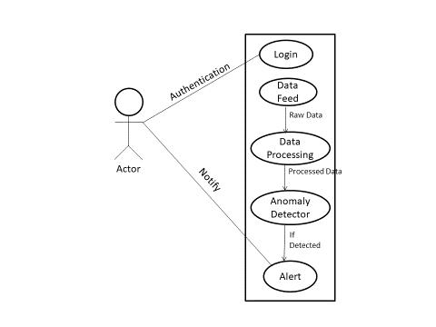

Fig 3.1: Use Case Diagram

**3.3 Data Flow Diagram**

**3.3.1 Level 0 DFD**

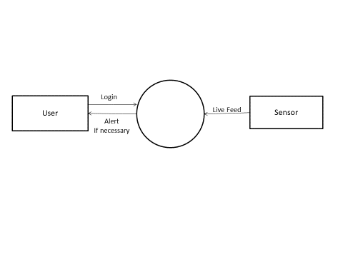

Anomaly

**Fig 3.2 :** level 0 DFD

**3.3.2 Level 1 DFD :**

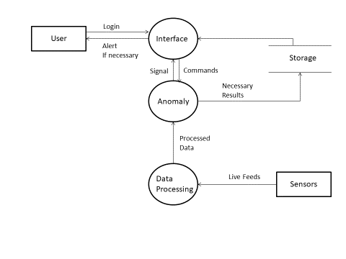

**Fig 3.3 :** level 1 DFD

**3.4 Flow Chart**

Start

Stream

Data Processing

Anomaly

Detected

Show alert

Continue

End

**Fig 3.4 :** Flowchart

**Chapter 4**

**Implementation and User Interfaces**

**4.1 Requirement For The Project**

The requirement of Analysis website is to allow getting information to solve problems in the corporation; going out and seeking opinions on optimal, actual, feelings, causes, and solutions and the user to put their own network data set. This website provides user to check where the anomalies in the data set on the bar-graph and also they can check their recommended network.

**4.1.1 Server Side**

We are using Web Server(Xampp Server) to provide comprehensive user interface to reviewer the will be solely responsible for deciding if a reported anomaly/event is false positive. Server Side also contains the base module that is responsible for reporting of anomalies to the reviewer. We have used **Time series analysis** comprises methods for analyzing time series data in order to extract meaningful statistics and other characteristics of the data. Time series forecasting is the use of a model to predict future values based on previously observed values. We have also used Arima model, **ARIMA**, short for 'Auto Regressive Integrated Moving Average' is actually a class of **models** that 'explains' a given time series based on its own past values, that is, its own lags and the lagged forecast errors, so that equation can be used to forecast future values.

**4.1.2 Client Side**

User would need a computer with an updated web browser to interact with our UI and at the client side we also need a reviewer to verify the authenticity of a reported event.

**4.2 System Module**

In this the module that act as an interface between Client and Server is Describe in detail.

**4.2.1 User Interfaces**

We are providing the user (reviewer) with all different kind of functionalities such as notifying him/her in case he/she is not attentive enough or needs a small break. In case critical anomaly is detected in absence of the reviewer our UI is capable enough to automatically show the Graph through the concerned authorities and report the bandwidth directly to them.

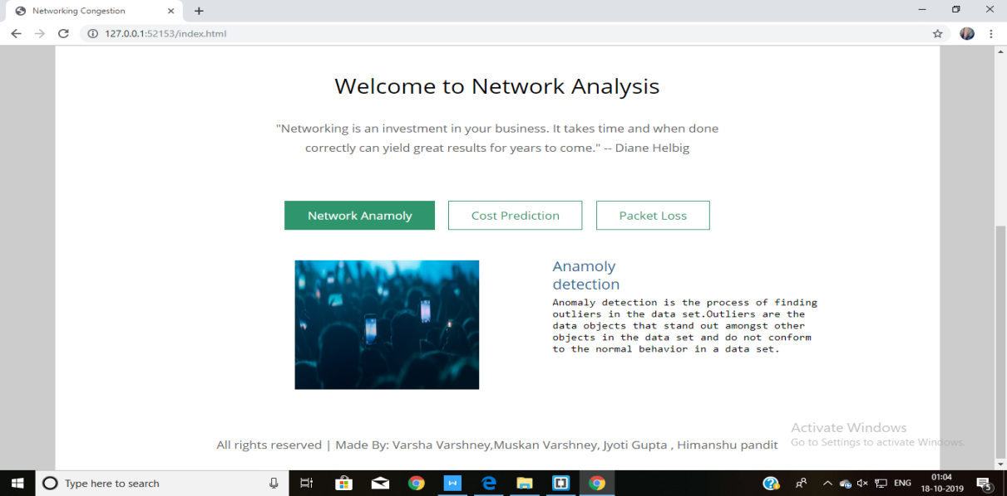

Fig. Home Page

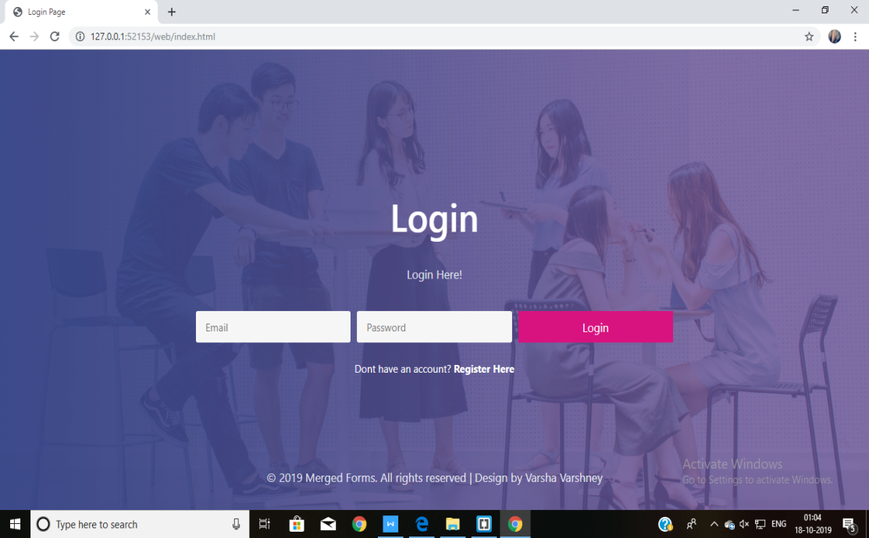

Fig.User Log-in Page



Fig.User Sign-In Page



Fig. Dashboard Page

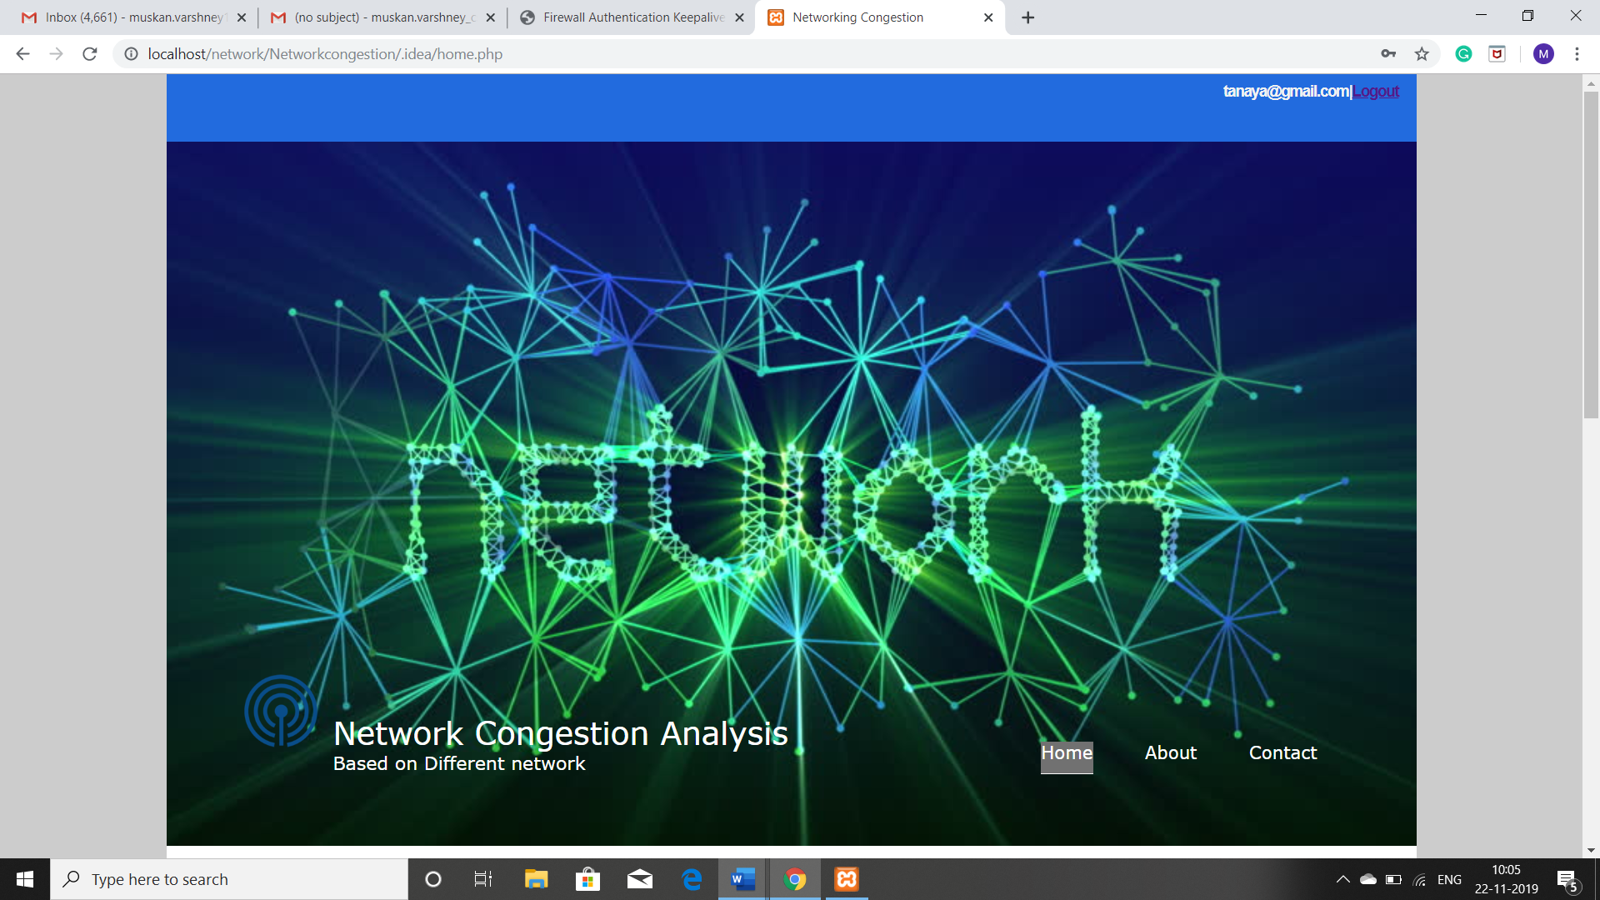

Home page

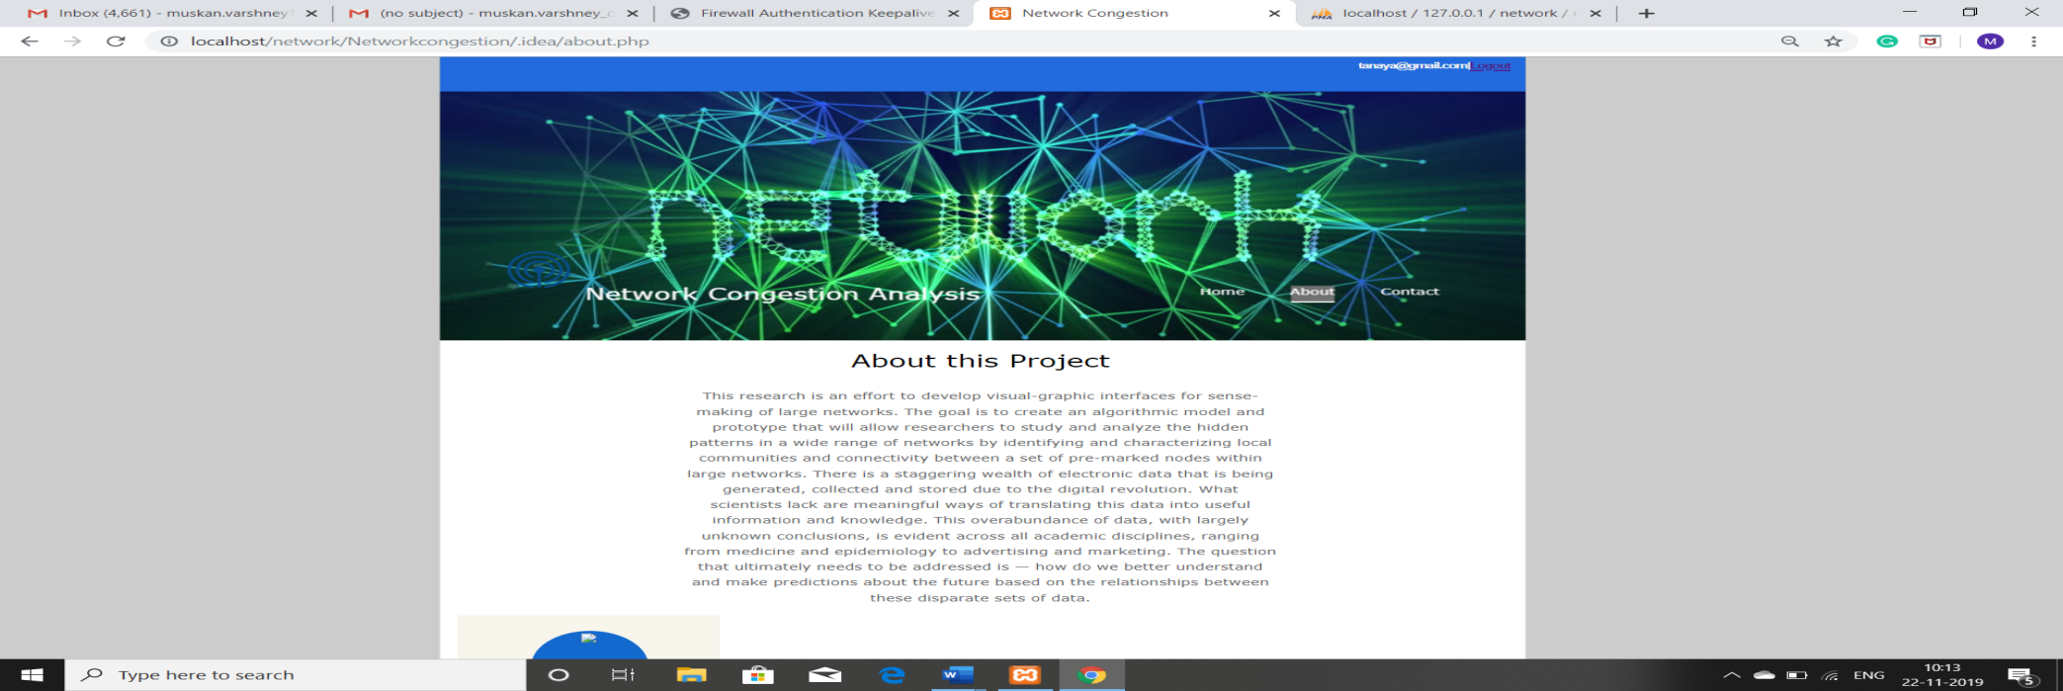

About pa

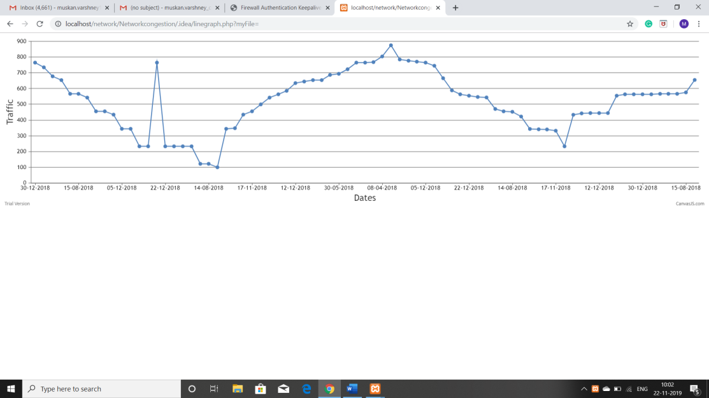

Graph

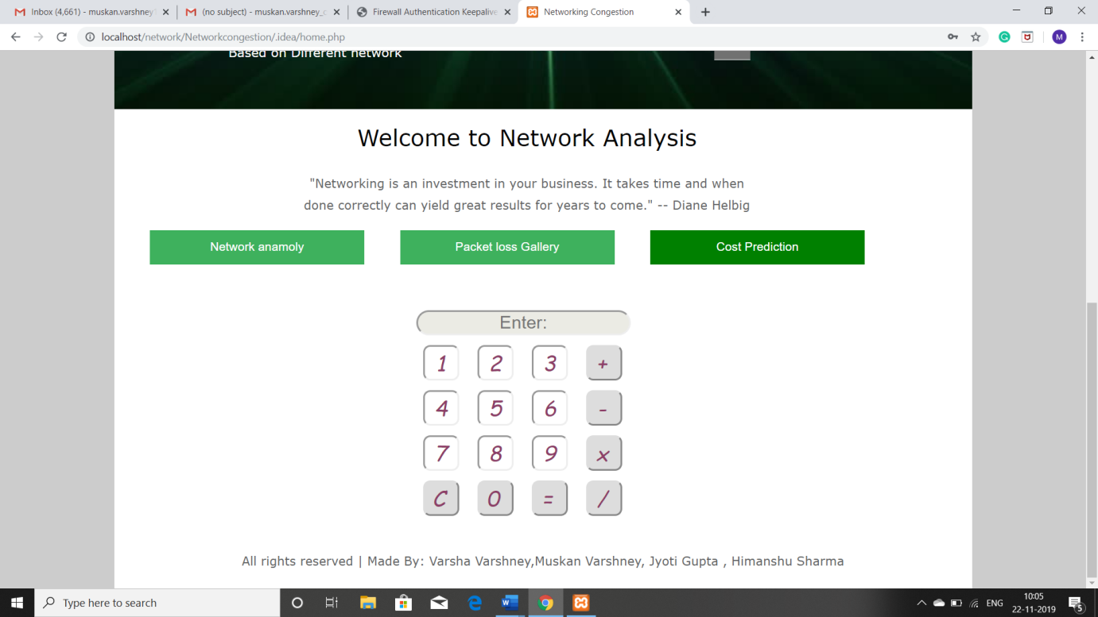

Cost prediction UI

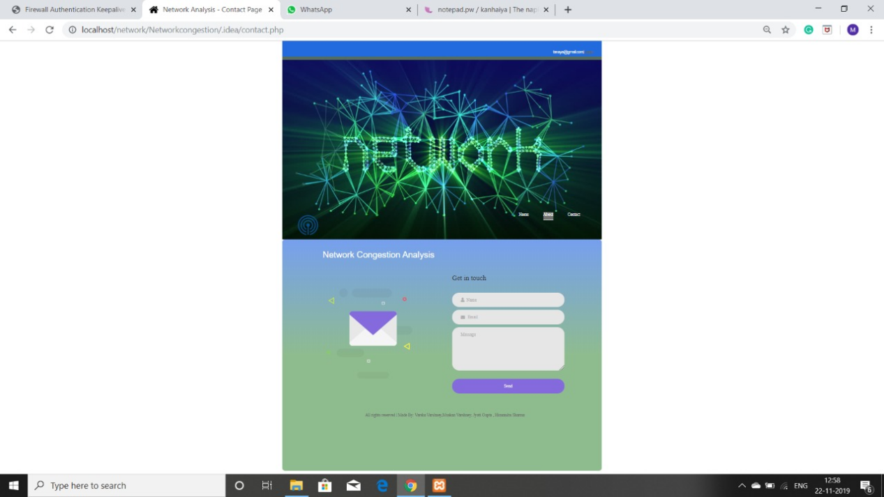

Contact page UI

**Chapter 5**

**Contribution Summary**

We are four group members in this group all are works the different languages and languages are HTML, CSS, JQUERY, JAVASCRIPT, BOOTSTRAP, SQL.

Muskan Varshney is working on the front end design using Html and CSS , using Html and CSS all modules including about, login, registration and network analysis. Modules description in as follow:

Home module - About module the description of the website is given on about module mainly three linker are given that are network anamoly, cost prediction and product loss.

Login module- Login module username and password are required to login into the dashboard if the user is not registered he can register himself clicking on register here button.

Registration module- If the user is not registered he can register himself by providing his details valid email is mandatory for the user because of the registering email it will be send to the user email address.

Network analysis- After logging in user move to the page this page store the data in the database currently this page is under working all functionality are not implemented till now.

Himanshu Sharma is working on back-end using php . By using the php all the functionality of all the module are manage . All the modules are about module login module, Registration, network analysis. Description of the module are-

Home module - In the about module there are three link in the module . Links are network anomaly, cost prediction, packet loss. It contains a bar to browse a data file then it will store to our database through MySQL in backhand then, we click on the result button . After the result we see the anomalies.

Login module- In the login module user enter their email-id and password to login the website. the functionality which is perform by the login button is manage by the php. It is verify their email-id and password it is correct or not into the database . The validation code is written into php. Registration module - In registration module user can register their self by entering their details that are required in the register module. After the user Registration module:- In registration module user can registe

their self by entering their self by entering their details that are required in the register module. After the user enter their details they are enter into database and their code is written into Php to save the data into database.

Network analysis :- We calculate the Cost of bandwidth in this module and also search which packet loss in this analysis.

Jyoti Gupta is working on the language JavaScript and MySQL .JavaScript operates on the front-end most frequently and operates entirely as an engine that is part of the user’s web browser. Of course, there are exceptions to this rule as noted in the brief mention of Node.js. Most typically, however, JavaScript works locally and only within the user’s web browser. MySQLis the relational database management engine that provides access to the data store, which, in this case, takes the form of an SQL (Structured Query Language) database. MySQL is run by PHP using one of three system plugins for PHP: MySQL (now considered legacy), MySQL (MySQL Improved), or PDO (PHP Document Object).A query is made in PHP to the MySQL database using SQL syntax, and data is returned, typically in the form of an array or associative array. Further manipulation in PHP can format the data to be transmitted as HTML content. Finally, through communication with Apache HTTP Server, this dynamically formatted HTML data is then sent to a user’s web browser.

In this project, Varsha is working on the part of J Query and bootstrap languages, By using Bootstrap Framework all the functionality of all the module are more effective .According to the our website, Bootstrap is the most popular HTML, CSS, and JS framework for developing responsive, first projects on the web. Additionally, Bootstrap requires J query to function. J query is an extremely popular and widely used JavaScript library, that both simplifies and adds cross browser compatibility to JavaScript.Some of the ways that frameworks can help me: Prevent repetition between projects. Utilize responsive design to allow your website to adapt to various screen. Sizes - mobile, desktop, and everything in between. Add consistency to design and code between projects and between developers. Quickly and easily prototype new designs, Ensure cross-browser compatibility.

**Chapter 6**

**Further Evaluation**

In this project, PHP and MYSQL both are used for the back-end. PHP is used for the web development and MYSQL is used for the database.

Hypertext Pre-processor is a general-purpose programming language which is originally designed for web development .It is a server side scripting language that is used to develop web application. PHP scripts can only be interpreted on a server that has PHP installed.

SQL is used for the database .It is used to generate queries from client program to the database. This can allow the users to execute a wide range of fast data manipulation. So,to basically put it, SQL is the main language that allows your database servers to store & edit the data on it.

In this project, PHPis used in Login and Registration page. SQL is used to store the data for further use and further validation. User authentication is very common in web application. It is a security mechanism that is used to restrict the unauthorized to member-only areas and tools on a site.

We’ve used the Bootstrap framework to make the form layouts quickly and beautifully. It includes HTML and CSS based design templates for image , button ,typography etc. It also gives you support for JavaScript plugins. Bootstrap’s responsive CSS adjusts to phones, tablets, and desktop.

We’ve also used the j Query, to improve the performance of the application. It helps to implement UI related critical functionality without writing hundreds of lines of codes. It is fast . It is extensible in nature. J Query is a JavaScript library that helps to simplify and standardize interactions between JavaScript code and HTML elements. J Query is a tool that helps streamline that process. J Query simplifies HTML document traversing, event handling, animating, and Ajax interactions for rapid web development You need to write fewer line of code while using J query, in comparison with JavaScript.

**CHAPTER 7**

**TESTING**

The implementation phase of software development is concerned with translating design specification into source code. The preliminary goal of implementation is to write source code and internal documentation so that conformance of the code to its specifications can be easily verified, and so that debugging, testing and modifications are eased. This goal can be achieved by making the source code as clear and straightforward as possible. Simplicity, clarity and elegance are the hallmark of good programs, obscurity, cleverness, and complexity are indications of inadequate design and misdirected thinking. Source code clarity is enhanced by structured coding techniques, by good coding style, by, appropriate supporting documents, by good internal comments, and by feature provided in modern programming languages.

**Structure Test**

Structure tests are concerned with exercising the internal logic of a program and traversing particular execution paths. Some authors refer collectively to functional performance and stress testing as “black box” testing. While structure testing is referred to as “white box” or “glass box” testing. The major activities in structural testing are deciding which path to exercise.

Validation Testing-

Validation testing is the process of ensuring if the tested and developed software satisfies the client /user needs. All the critical functionalities of an application must be tested here.

In validation testing we are validate the login form , registration from,nav bar and feedback form in contact page. In Registration page , we are validate the password , email ,space(like we enter only spaces it does not take the white space it show please enter the required details ). In password validation we test the length of the password and confirm password and password is same.In feedback form their is no validation

we enter the data and save into the database and on NAV bar we show that the mail id of the client whose login the website.

 

 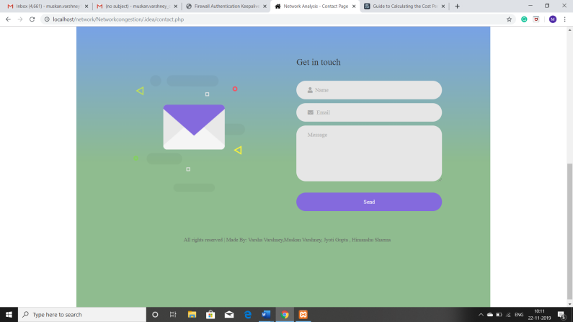

**Source code of the validation testing:**

**Login Module:**

Login Module is used by the client to access the website . login Module contain Email-id and Password through which client can access their account if client have their account. if it does not have their account client can made an account through the registration page.

Source code of login page :validation.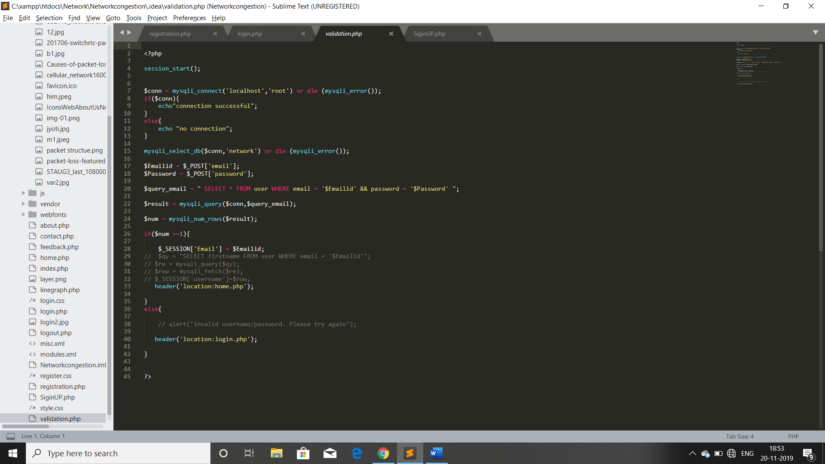

**Register Module:**

Register module is used by the client ,when client will have not their account to access the website. registration page contain

First name , Last name , email-id, password , confirm password through which client would made their account ,and access the account to use website .registration module have validation (password validation, Email validation ,space validation, password length validation, password and confirm password should be same validation). Source code of validation in Registration page.

HomePage: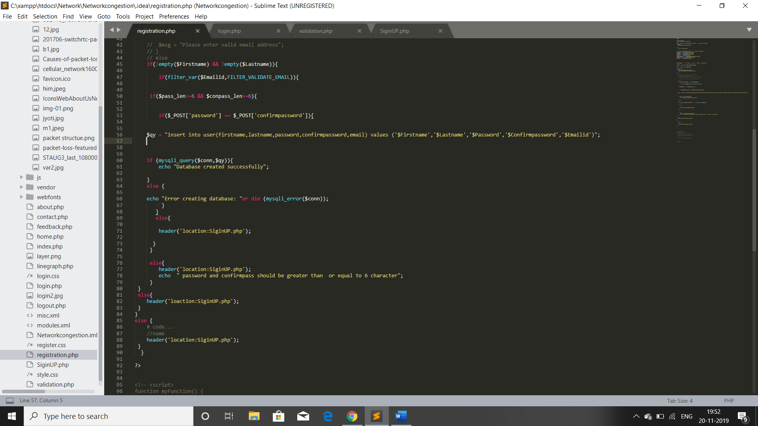

On the home page we can browse the file and by browsing the CSV file show the graph by the python code through which we can find the bandwidth of the network and calculate the cost of the traffic.

**Source code of Graph:**

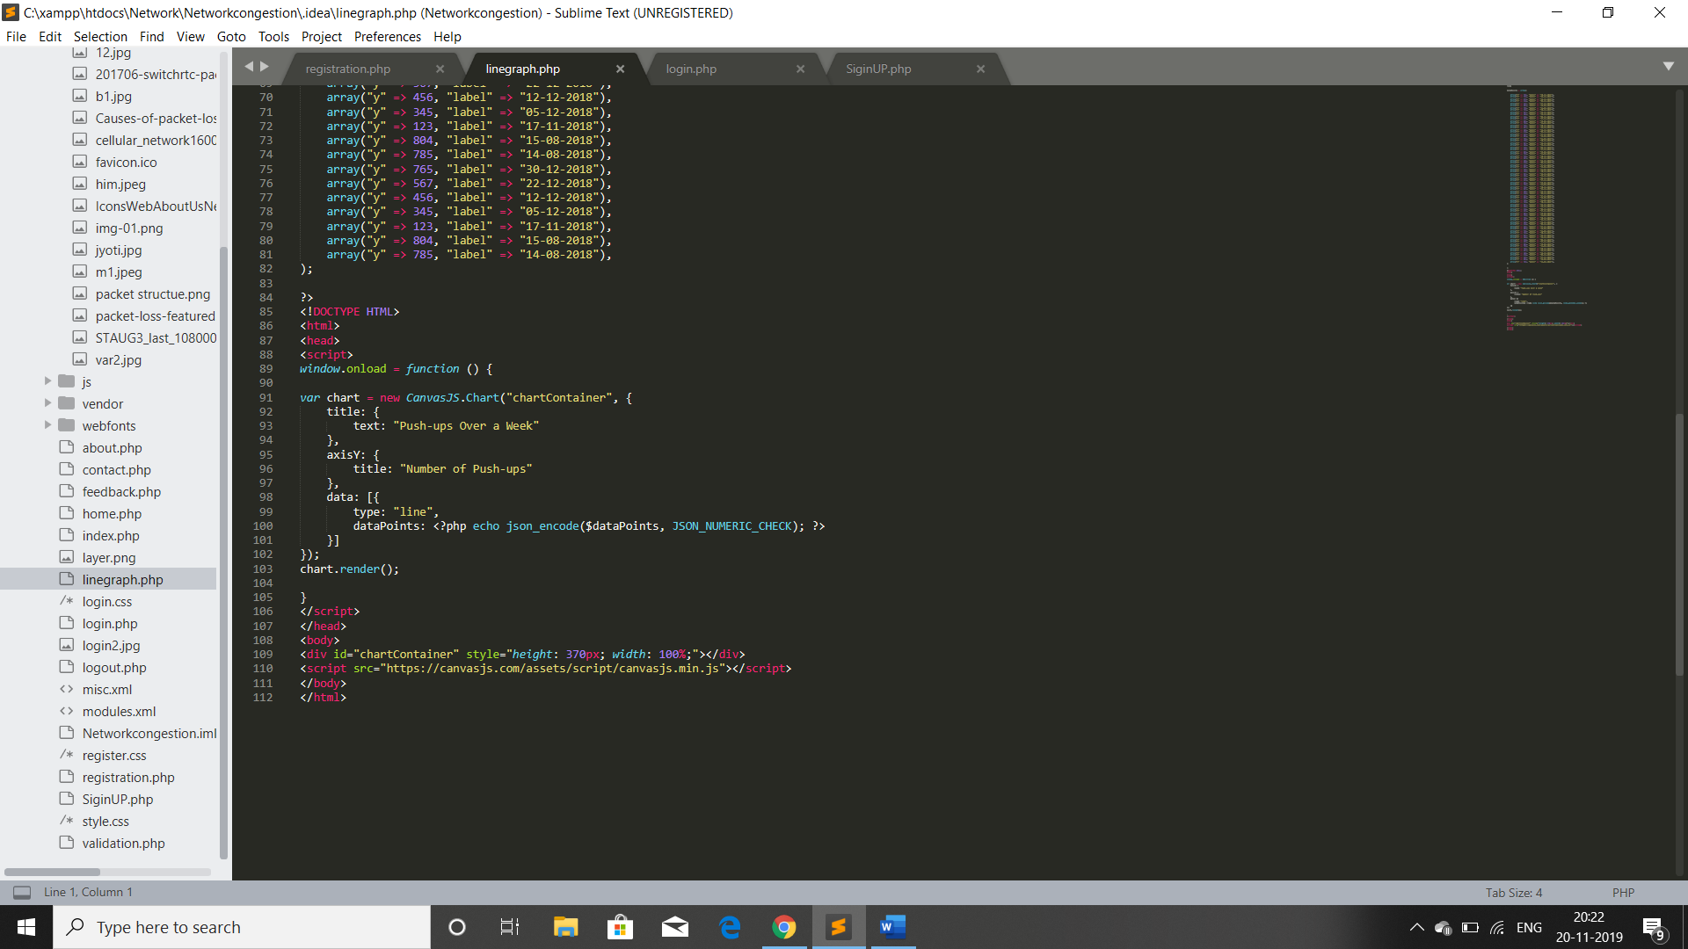

**Feedback module:**

Feedback module in the contact page. feedback is given by the client and this feedback is save into the database.

Source code of feedback:

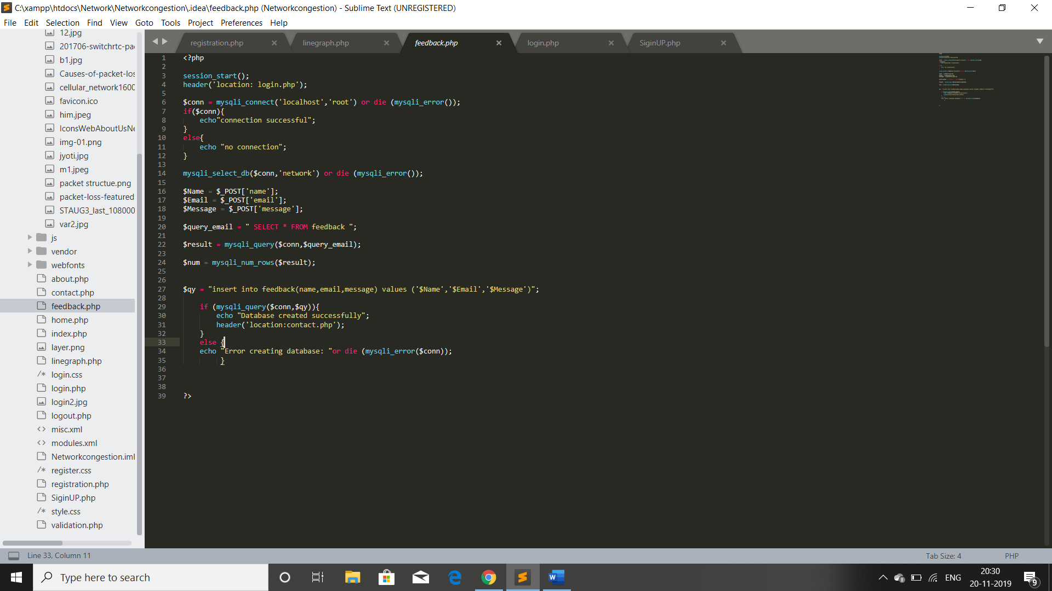

**Log-out module:**

Through the log-out, client close their account and their session is destroyed which was created when account is login.

Source code:

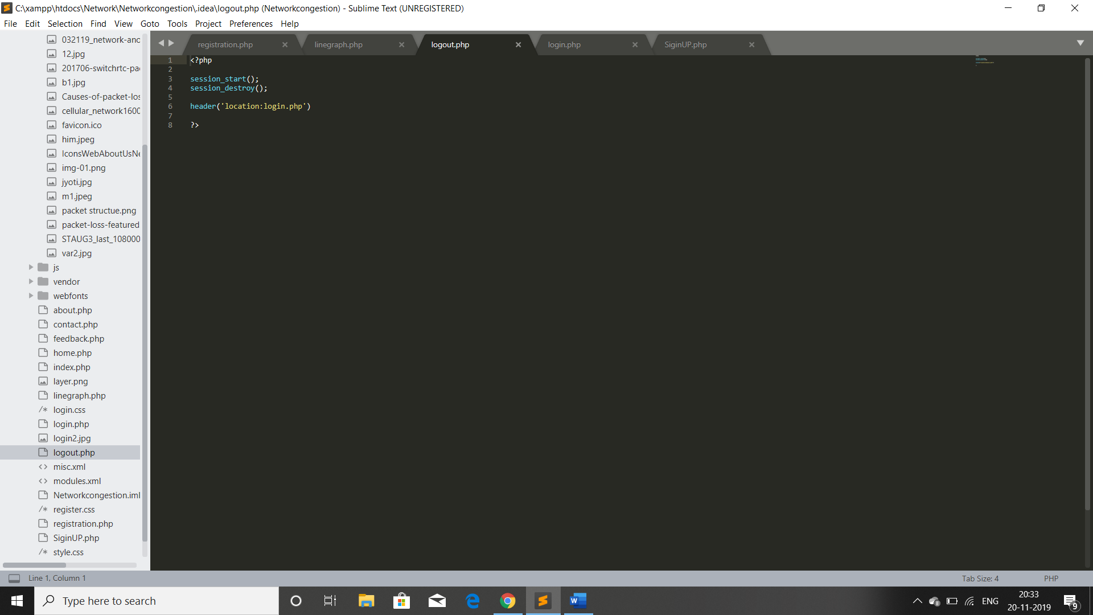

**Chapter 8**

**Conclusion**

We have developed first ever solution to a widely existing problem using the advance in our field. This solution can help avoiding anomalies in the network and can also help in maintaining the congestion on the network this can also be used as a base for another application that may even remove the role of users there can be small extension of the project such as analyse the network and remove the anomaly,

This system analyse the congestion by data set and the result of analysis is re analyse to visualize the graph that will show on the screen after browsing the data set file which is in the format of CSV and click submit it, graph will show the then we calculate by the help of cost prediction calculator**.**

**Future Evaluation**

In this project we cover almost all the process which was wrote in our synopsis but The bandwidth graph is still static, it will be dynamic and whatever validation was put in it,that validation is not happening in popup form, then we will do it further.We did not have enough time to be able to show Popup messages in our website by using the technology of JavaScript. In the future, we will use JavaScript technology to make it pop up, so that we will be able to show ,such Popup messages on our website.

**Chapter 9**

**References**

* ["HTML 5.2 W3C Recommendation"](https://www.w3.org/TR/html5/introduction.html" \l "syntax-errors). *W3.org*. [W3C](https://en.wikipedia.org/wiki/W3C" \o "W3C). 14 December 2017. § 1.10.2 Syntax Errors. Retrieved 29 June 2017.
* [W3C](https://en.wikipedia.org/wiki/W3C" \o "W3C):*[Cascading Style Shees, level 2 revision 1](http://www.w3.org/TR/2011/PR-CSS2-20110412/) CSS 2.1 specification (W3C Proposed Recommendation)*
* ["Using PHP from the command line"](https://php.net/manual/en/features.commandline.php). *PHP Manual*. The PHP Group. Retrieved 2009-09-11.
* Github id- https://github.com/Varsha67/FullStack-A-33-80-C-28-D-29-repo